TASK 2 – Sales Performance Analysis
Notebook link (code included):
https://colab.research.google.com/drive/1HaBSR_BPHPM7sDoD4Gj97f37nwqGOrnn
C:\Users\tmadh\Downloads\Super_Store.ipynb
Visualizations:
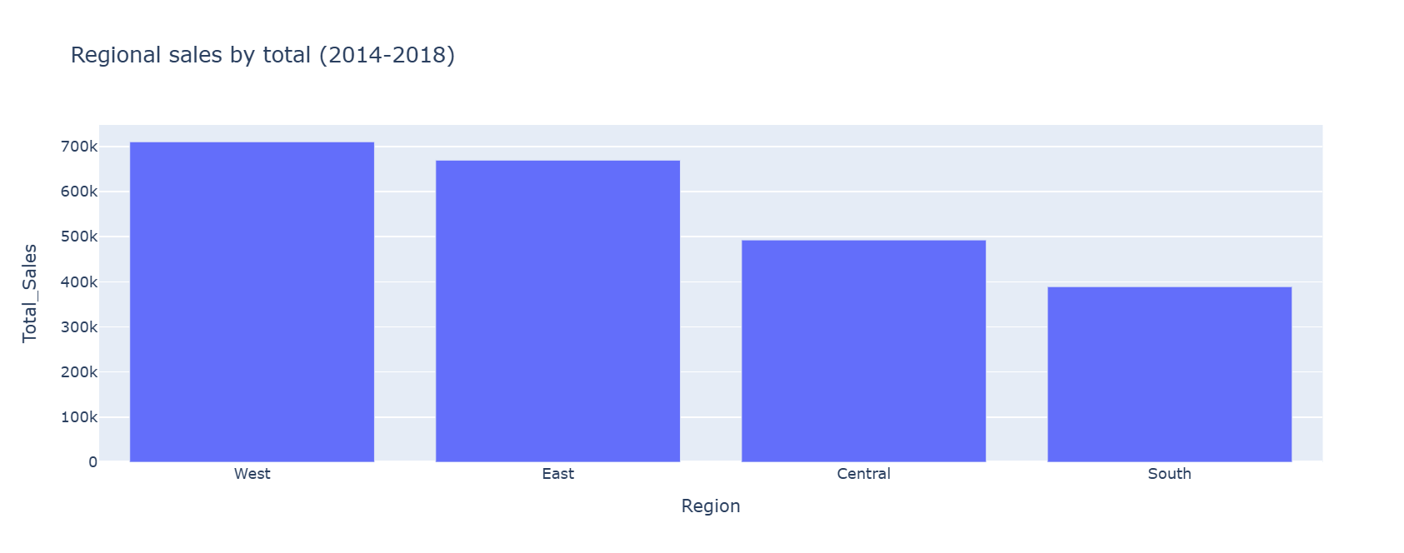
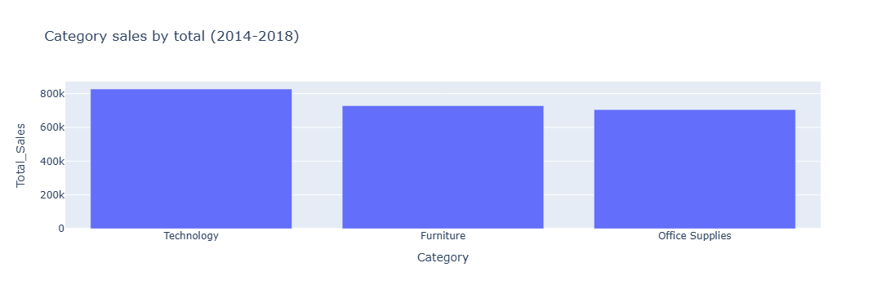
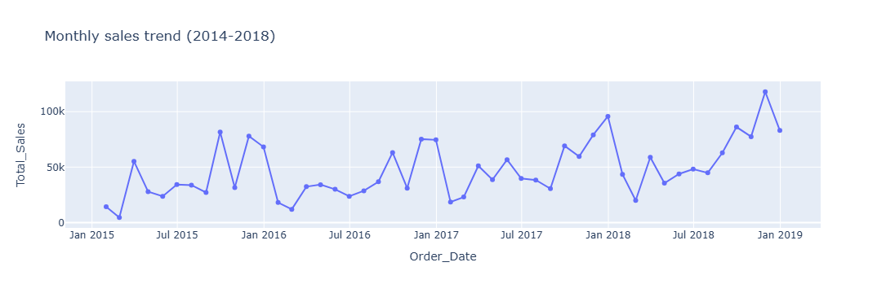
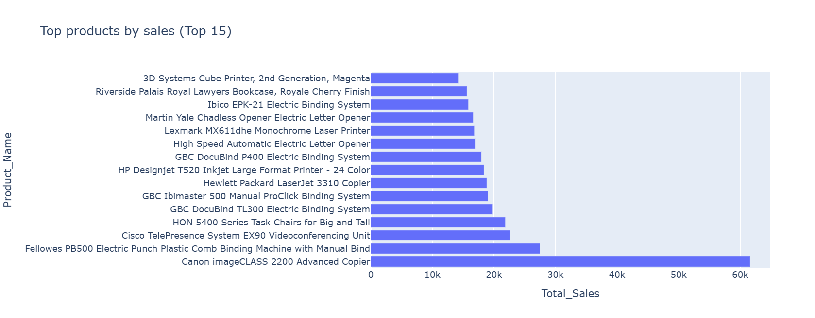

Short Summary:
The project was aimed at exploring customer transactions in order to determine their purchase behaviour and segments as well as possible churn cases. Customer transaction data were cleaned and processed via feature engineering, and then customers were segmented based on the use of RFM analysis. As a result of the analysis, there appeared different types of customers, including high-value, frequent, and churn-prone customers.
The purchase pattern analysis proved that regular customers brought quite a lot of revenue while there were many inactive customers that could pose some retention challenges. Thus, it becomes evident that proper retention efforts should be implemented in Alfido Tech.
In general, the results obtained during the analysis can be highly useful for Alfido Tech since they may promote the development of new customer engagement and retention strategies.

